**Terraform:**

Infra provisioning with terraform

**Purpose:**

* generally, terraform is used to create infrastructure
* to be more specific it creates virtual infrastructure

**Do we have alternatives for Terraform?**

* **AWS =>** CloudFormation
* **Azure =>** ARM Templates

**­How to write terraform scripts?**

* Terraform has its own Domain Specific Language

**Terraform building blocks**

1. Resource: atomic unit of creation
2. Variables: passing different values
3. Data sources:
4. Output: information to be shown to the user
5. Provider: where do you want to create infra

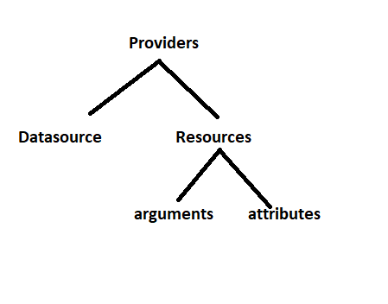

**Popular use cases**

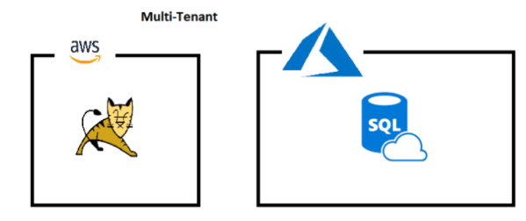

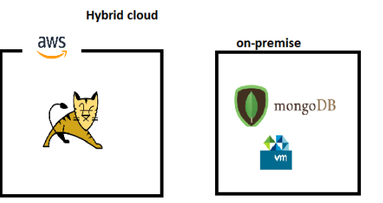

**Basic terraform DSL**

* Input for terraform is folder/directory
* Terraform will pick all the files in the input folder with *.tf
* Provider syntax

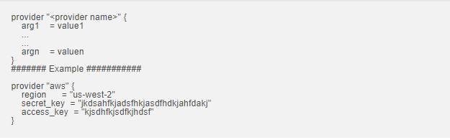

**Resource syntax**

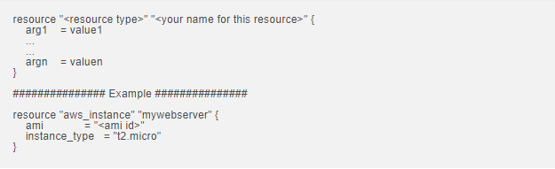

**Execution steps**

1. Create a directory with name hello-aws
2. Create a file inside a directory “hellow-aws” named “main.tf” with above contents

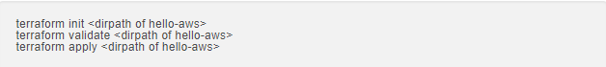

**Architecture to be realized**

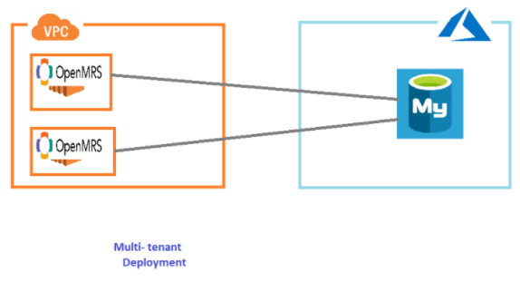

**AWS side of Architecture**

* Manual Steps:
  + Create VPC with cidr range ‘10.10.0.0/16’
  + Add two subnets to VPC with cidr ranges ‘10.10.0.0/24’ and ‘10.10.1.0/24’
  + Add internet gateway =>
  + Add a route to internet gateway to exisiting or new route table
  + Add a security group for openmrs server => 22,8080 opened for usage
  + create a key value pair
  + create 2 ec2 machine in 2 subnets created above

Using attributes of one resource in arguments of another resource

**Syntax**



* Note: this also called as resource dependency
* Resource dependency determines the order of execution of resources

## What happens when you execute terraform apply?

Terraform apply command does the following * Every terraform apply command creates a plan if you dont pass the pass. Plan can be created using terraform plan * Before terraform creates anything it will check state file. If state file is not present. It will create everything. * State will be maintained by terraform by making necessary calls to the provider

## What terraform init does?

Terraform init downloads the provider executable into local directory “. terraform" in the working directory of terraform

## Commands used in the session

## 

## Sample script without provider in Paris Region of AWS

## ## for script finds the templates ##

## Area to be improved

## Making terraform script generic

## Need to be provisioning

## How to make terraform scripts generic

## Variables

## Our scenario

## In the case of sample architecture, I have created the following variables in a file called as vars.tf

## ## To find vars.tf in templates ##

## Using variables in terraform resources/providers/outputs

## To find details check the templates

## The commands used to create infra

## 

## What is that we have archived so far

## We have able to create ec2 machine and generalize the behaviour.

## Now we can use this script to create ec2 machines in any account & also in any region.

## We need to install tomcat

## Look at the script in terraform to create two aws ec2 machines & install tomcat

## ## find the templates ##

## Reusability in terraform using modules

## Module: reusable terraform script/template is called as module

## Things to know:

## Module is nothing but organising the same terraform script in bit different

## We have sample architecture terraform script. Now I want to convert that to module

## Like all the components of terraform. Module also has arguments & attributes

## Variables become arguments

## Outputs become attributes

## In the calling script you will import module

## There are many modules which you can use. These modules are available in terraform registry

## For modules find the templates

## How to create module:

## Let’s refactor sample architecture

## Ensure all the variables are written in a file called as variables.tf (recommendation)

## Ensure all the outputs are written in a file called as output.tf (recommended)

## Whenever you are using local modules try to use the following directory structure 🡺 terraform script 🡺 modules < module name > main.tf variables.tf output.tf

## To find check the template

## Multi user’s scenario

## 

## As mentioned in the above images we need to solve the problem.

## Why this problem

## Whenever terraform apply command is executed, a state file gets created.

## Default location of state file current directory ( when you execute the terraform command )

## Possible solution

## Try to store state file in common location which is accessible to both

## This is called as backend

## What about backend with multiple environments

## Solutions to this is terraform work space